Triakis Icosahedron

Definition
# Source: AI Source: Provided by: [Data Path: Persons Table -> ID Column: 1, Name_En Column: Motasem Essam] -> From: [ChatGPT] on [7/25/2026]
A Triakis Icosahedron is a convex Catalan solid composed of 60 congruent isosceles triangular faces, 90 edges, and 32 vertices.
It is the dual polyhedron of the Truncated Dodecahedron, an Archimedean solid. Its shape can be understood as an icosahedral form with triangular pyramids added to the faces of an underlying icosahedron.
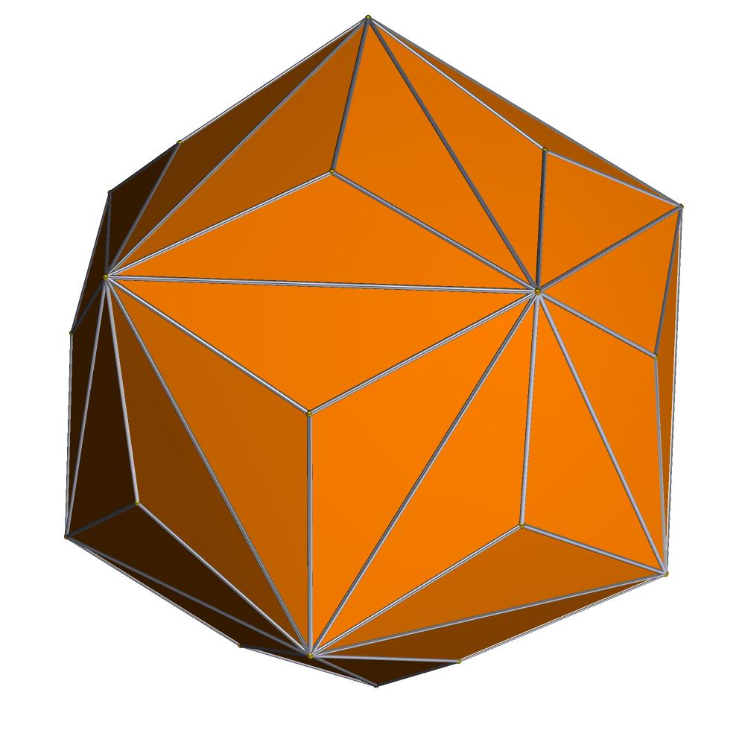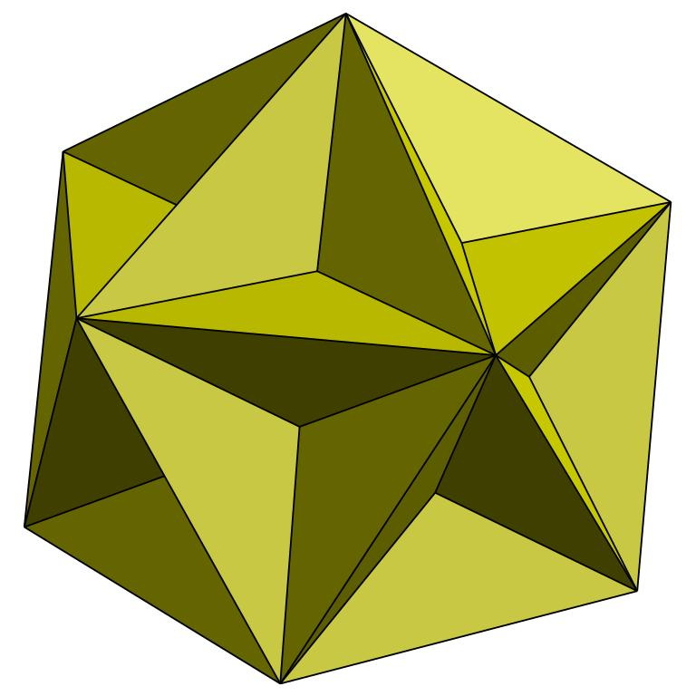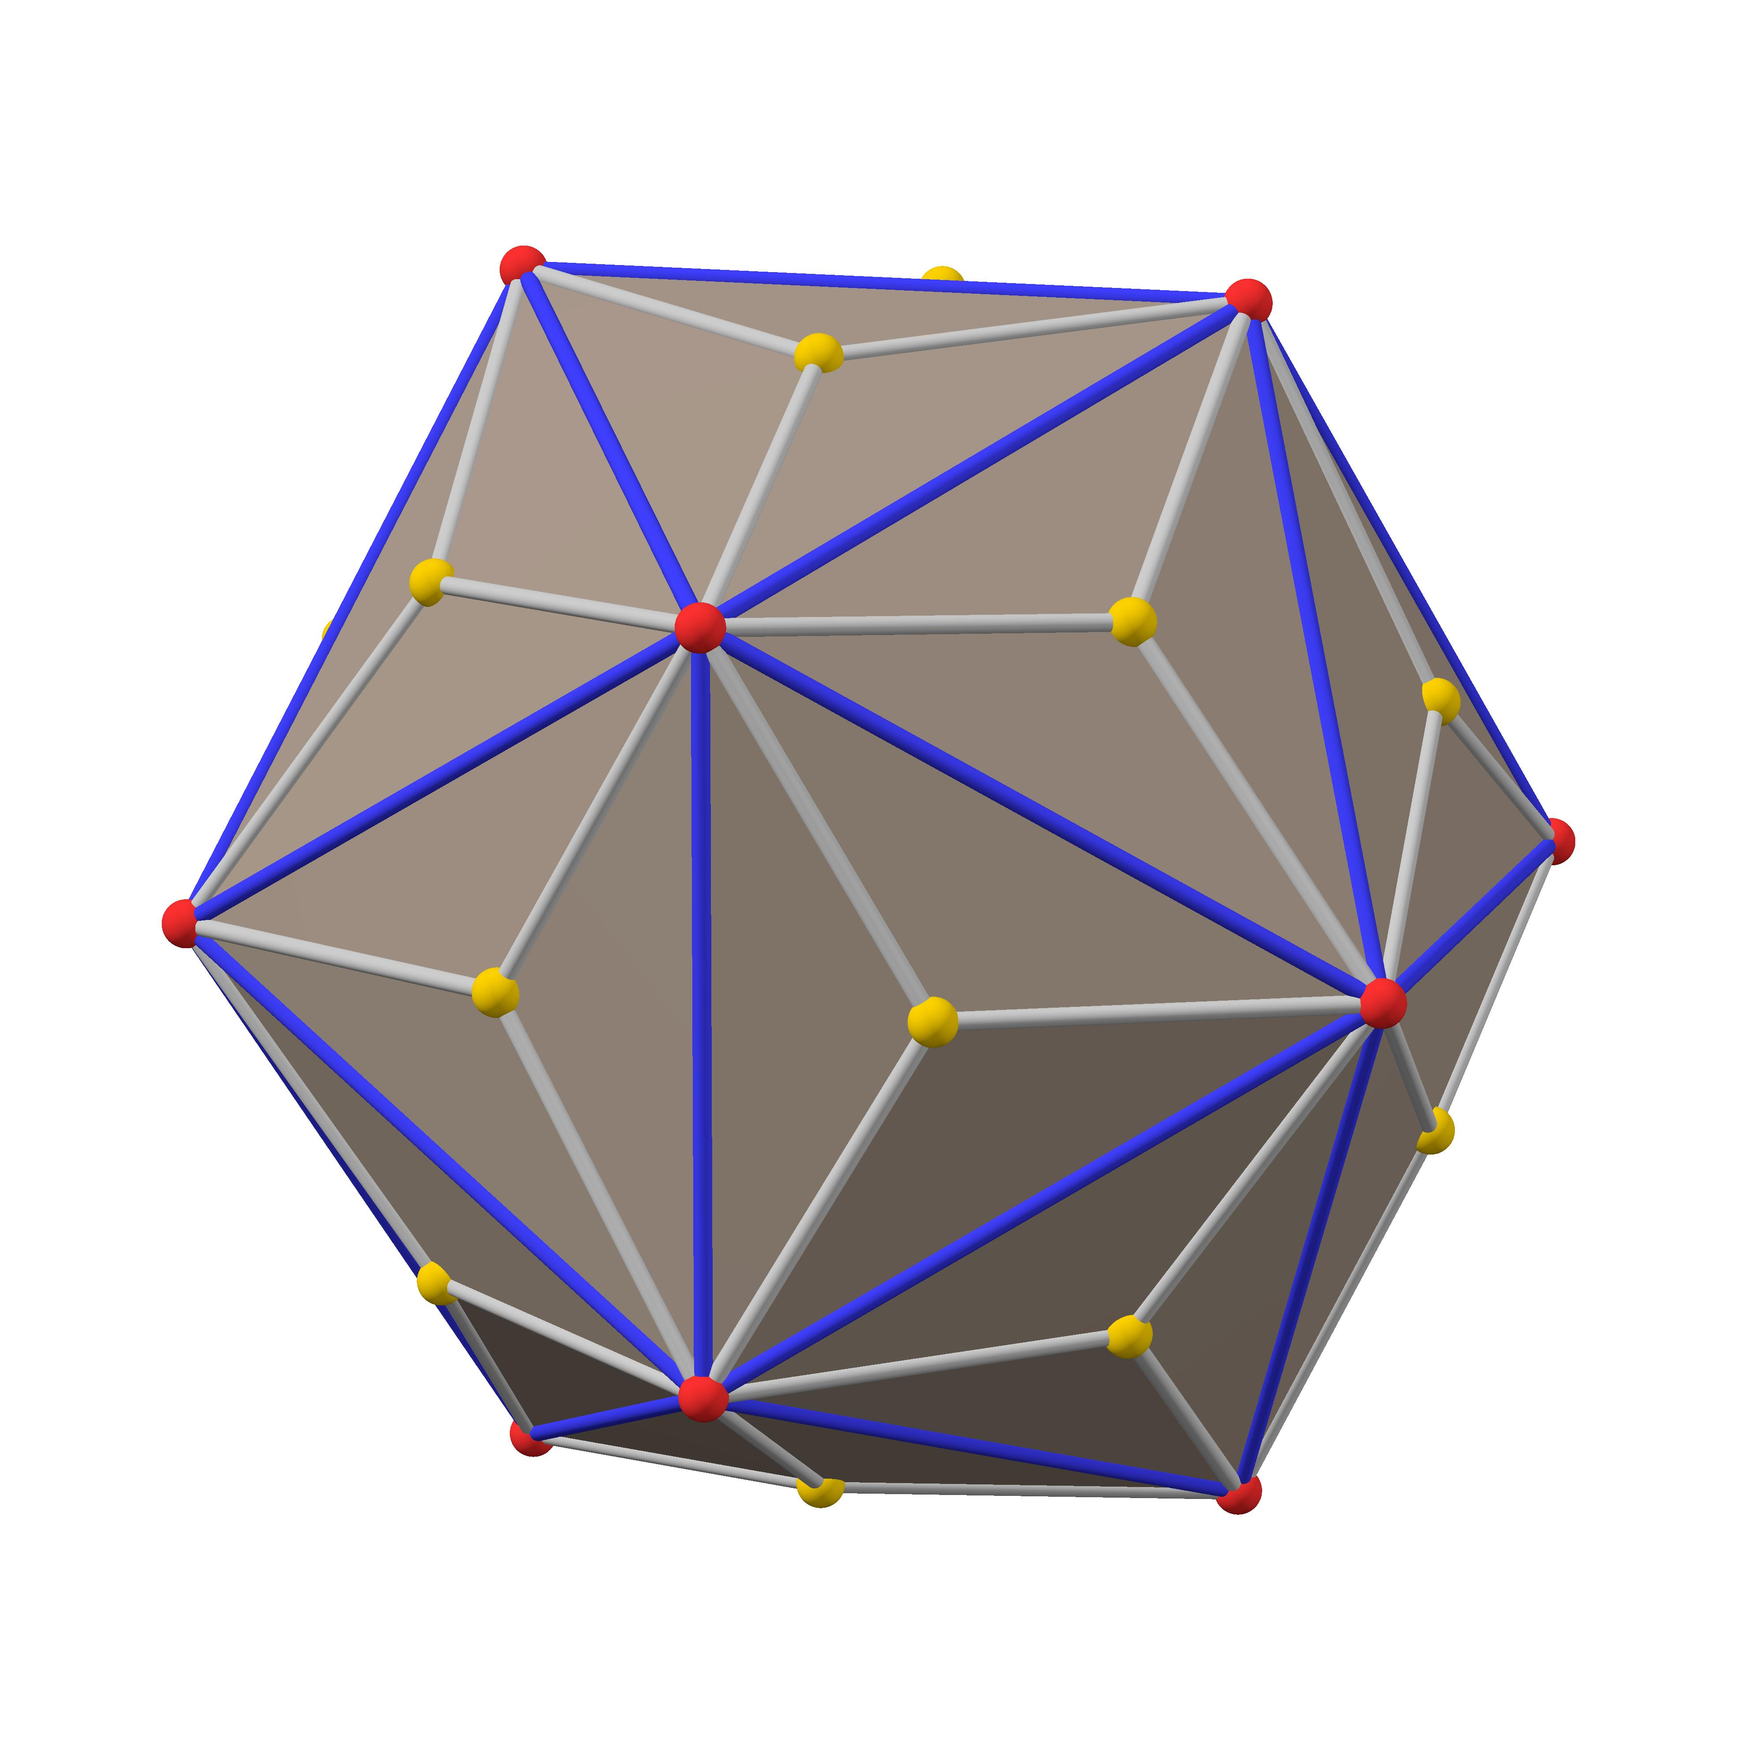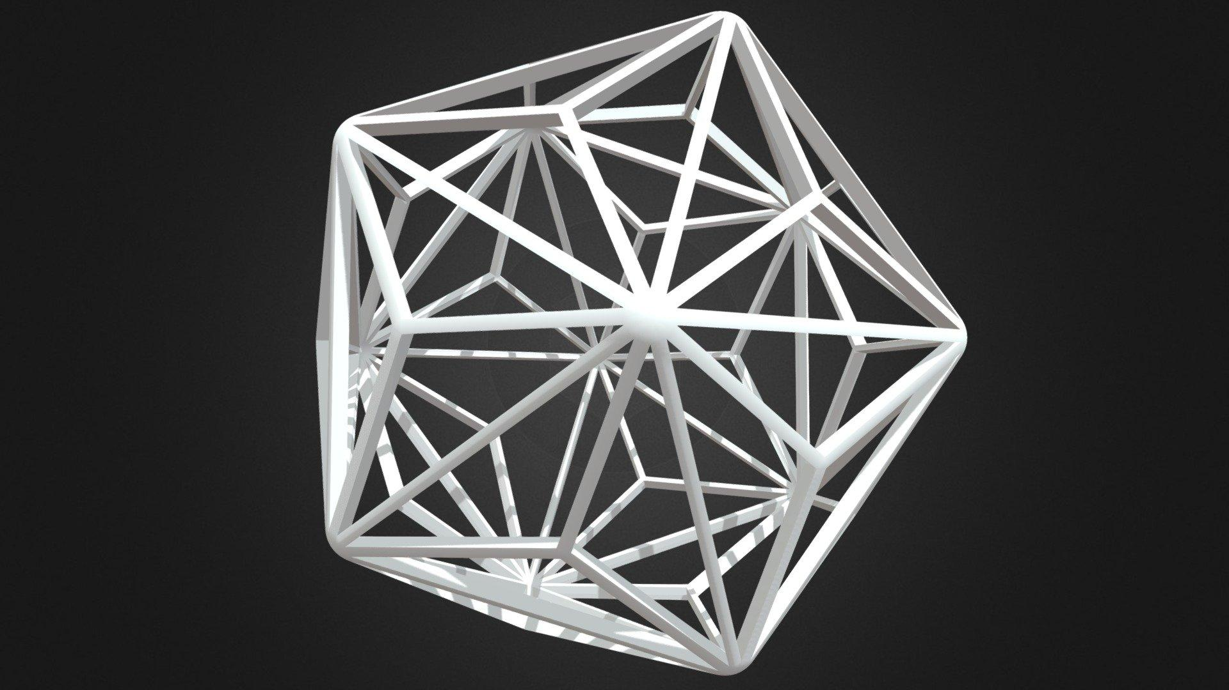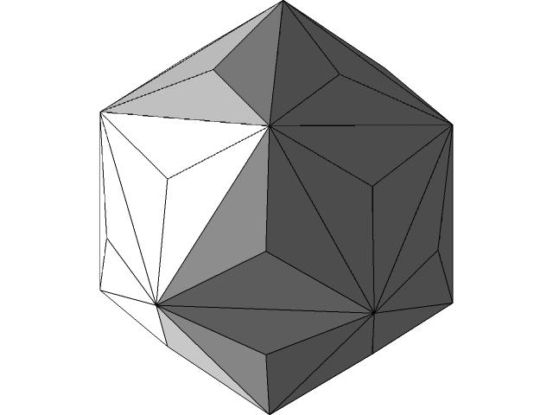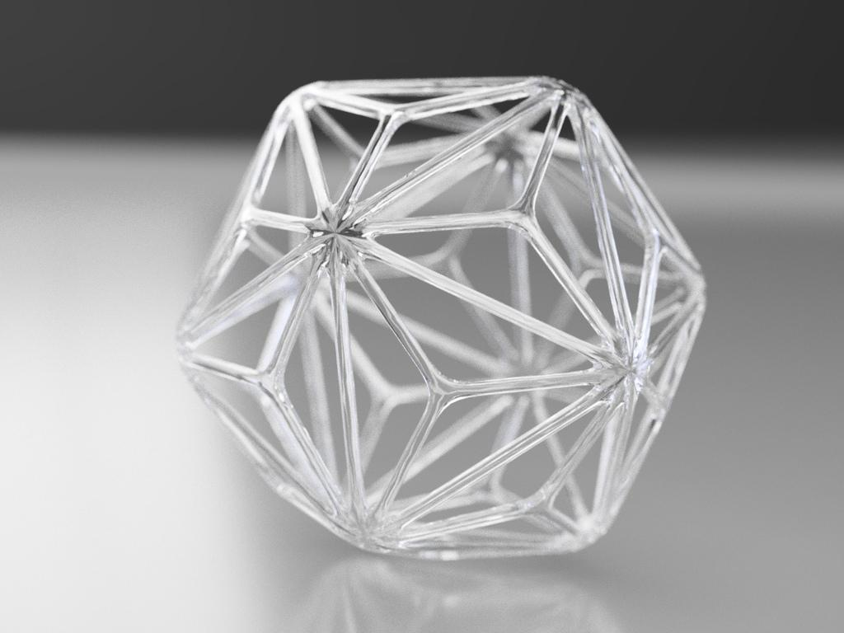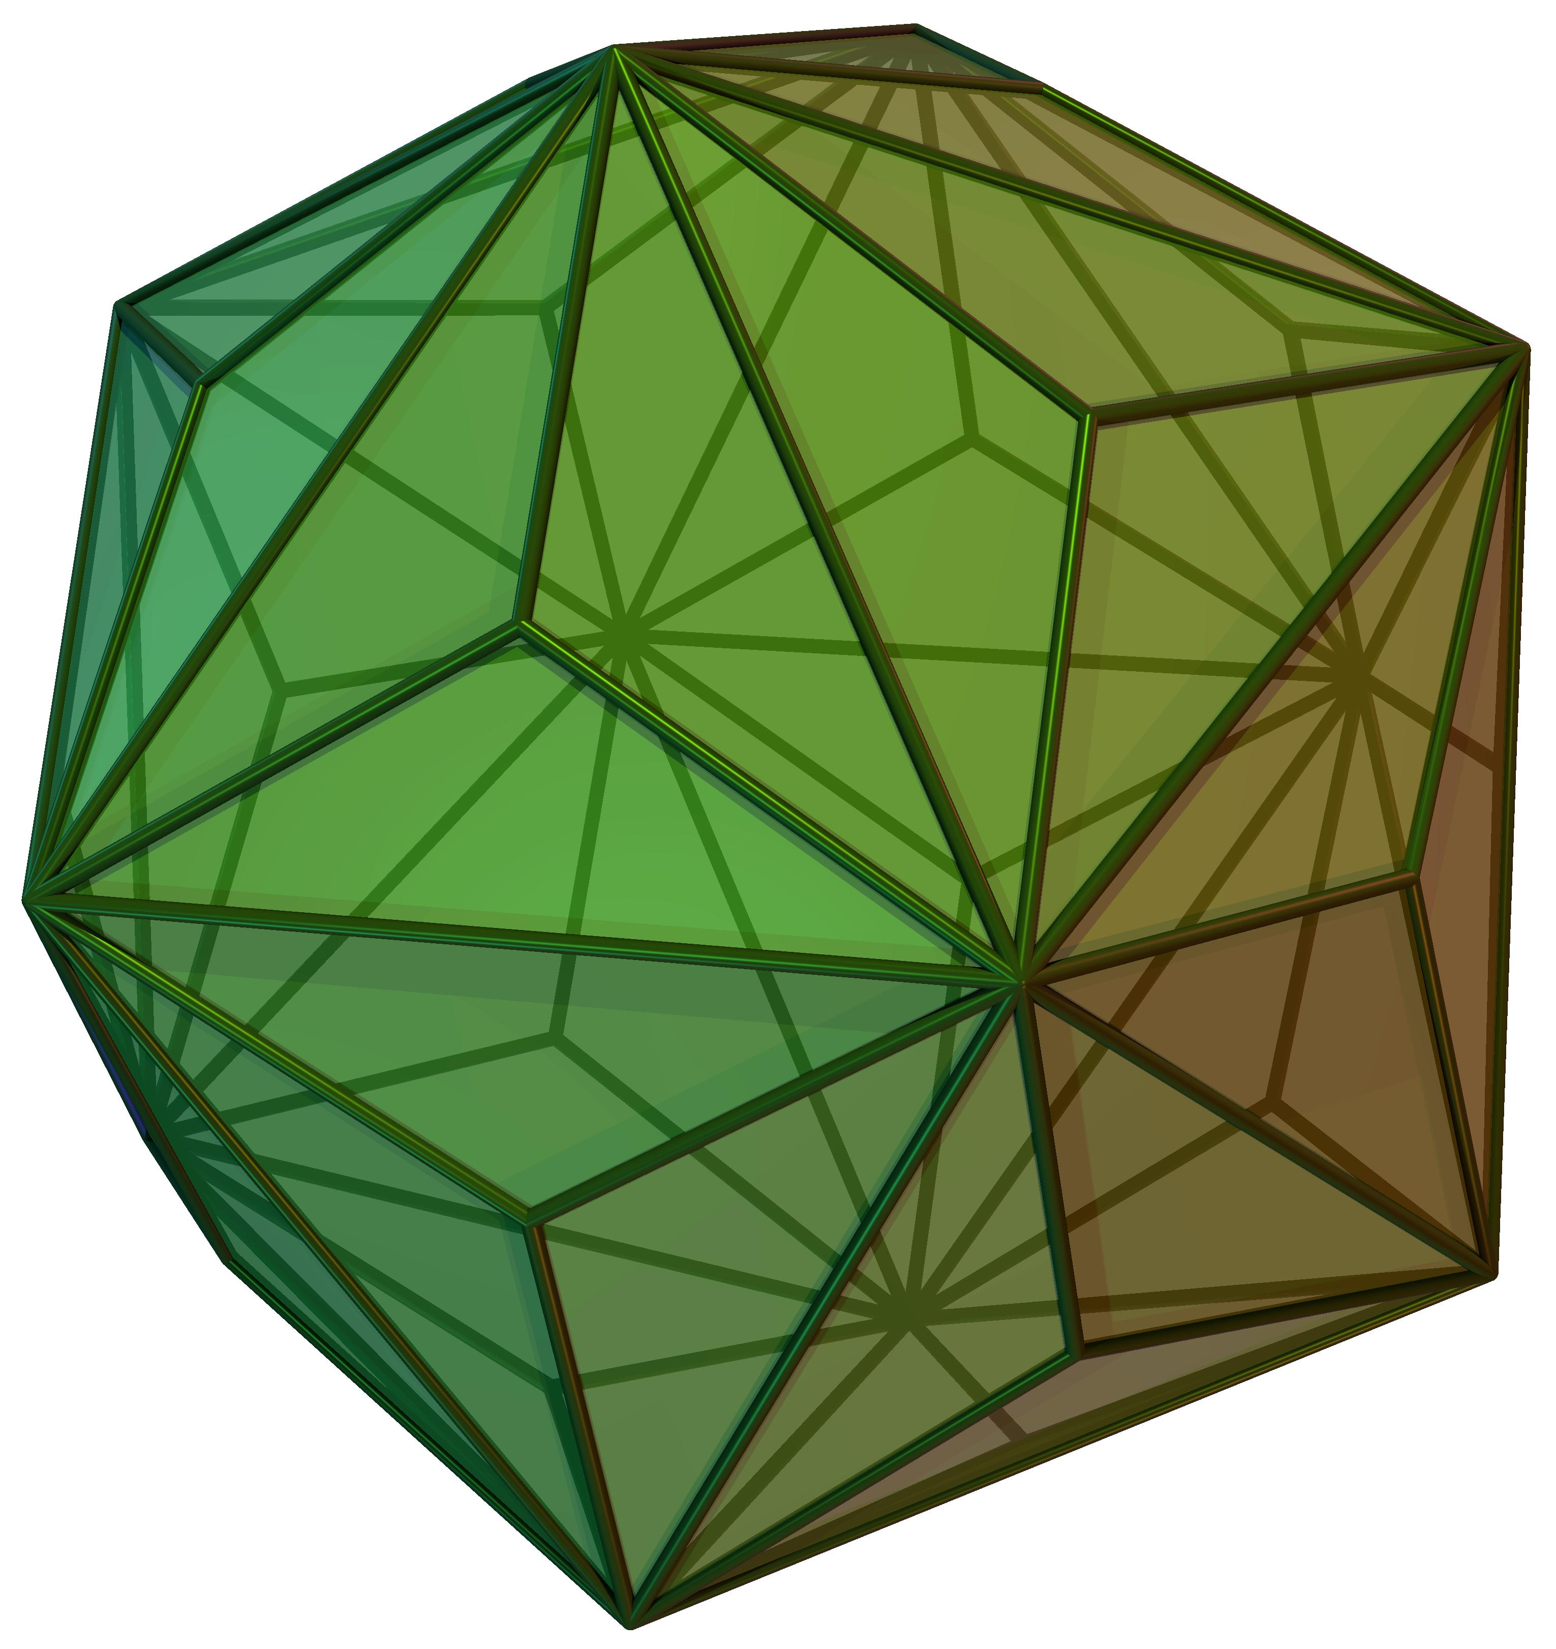

Simple Definition
# Source: AI Source: Provided by: [Data Path: Persons Table -> ID Column: 1, Name_En Column: Motasem Essam] -> From: [ChatGPT] on [7/25/2026]
The Triakis Icosahedron is a 3D solid with many sharp triangular faces. Each face is an identical isosceles triangle, and the faces meet in two different types of vertices:
- 20 vertices where 3 triangular faces meet.
- 12 vertices where 10 triangular faces meet.
It has the same overall icosahedral symmetry as an icosahedron.

Geometric Structure
# Source: AI Source: Provided by: [Data Path: Persons Table -> ID Column: 1, Name_En Column: Motasem Essam] -> From: [ChatGPT] on [7/25/2026]
The Triakis Icosahedron has the following structure:
- 60 triangular faces: all congruent isosceles triangles.
- 90 edges: divided into two different length groups.
- 32 vertices: divided into two groups according to how many edges meet there.
- Convex shape: all its faces form an outward-bulging solid without self-intersections.
- Icosahedral arrangement: its structure has fivefold, threefold, and twofold rotational symmetry.

Face Structure
# Source: AI Source: Provided by: [Data Path: Persons Table -> ID Column: 1, Name_En Column: Motasem Essam] -> From: [ChatGPT] on [7/25/2026]
The Triakis Icosahedron contains 60 identical isosceles triangular faces.
Each triangular face has:
- Two equal shorter sides.
- One longer base side.
- One obtuse angle.
- Two equal acute angles.
For the standard form obtained as the dual of a unit-edge truncated dodecahedron, the approximate face angles are:
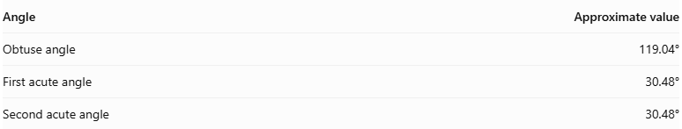
Angle | Approximate value
Obtuse angle | 119.04°
First acute angle | 30.48°
Second acute angle | 30.48°
The angles add up to 180°, as required for a triangle.

Edge Structure
# Source: AI Source: Provided by: [Data Path: Persons Table -> ID Column: 1, Name_En Column: Motasem Essam] -> From: [ChatGPT] on [7/25/2026]
The solid has 90 edges, divided into two groups:
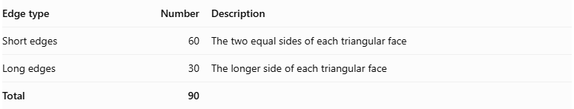
Edge type | Number | Description
Short edges | 60 | The two equal sides of each triangular face
Long edges | 30 | The longer side of each triangular face
Total | 90
For the standard model based on a truncated dodecahedron with unit edge length:
- Short edge length: approximately 2.0991 units.
- Long edge length: approximately 3.6180 units.
- Short-to-long edge ratio: approximately 0.580 : 1.
These lengths depend on the chosen scale; the ratio does not.

Vertex Structure
# Source: AI Source: Provided by: [Data Path: Persons Table -> ID Column: 1, Name_En Column: Motasem Essam] -> From: [ChatGPT] on [7/25/2026]
The Triakis Icosahedron has 32 vertices, divided into two groups:
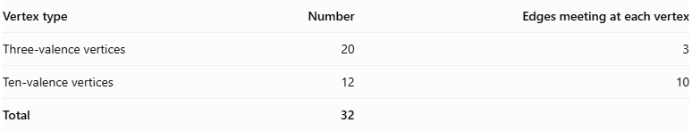
Vertex type | Number | Edges meeting at each vertex
Three-valence vertices | 20 | 3
Ten-valence vertices | 12 | 10
Total | 32
- 20 three-valence vertices: three edges and three triangular faces meet at each vertex.
- 12 ten-valence vertices: ten edges and ten triangular faces meet at each vertex.
The two groups correspond to the vertices of an inscribed icosahedron and dodecahedron, respectively.

Mathematical Properties
# Source: AI Source: Provided by: [Data Path: Persons Table -> ID Column: 1, Name_En Column: Motasem Essam] -> From: [ChatGPT] on [7/25/2026]
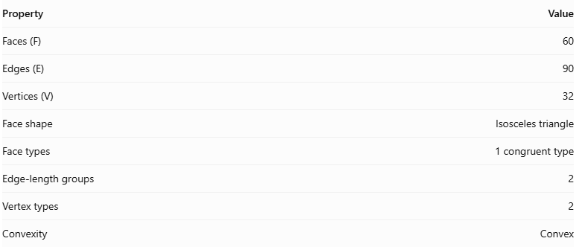
Property | Value
Faces (F) | 60
Edges (E) | 90
Vertices (V) | 32
Face shape | Isosceles triangle
Face types | 1 congruent type
Edge-length groups | 2
Vertex types | 2
Convexity | Convex
Euler's formula
For a convex polyhedron:
$$V-E+F=2$$
Substituting the Triakis Icosahedron values:
$$32-90+60=2$$
Therefore, it satisfies Euler's polyhedron formula.
Face-angle sum
Each triangular face has an interior angle sum of:
$${119.04}^{°}+{30.48}^{°}+{30.48}^{°}={180}^{°}$$

Symmetry
# Source: AI Source: Provided by: [Data Path: Persons Table -> ID Column: 1, Name_En Column: Motasem Essam] -> From: [ChatGPT] on [7/25/2026]
The Triakis Icosahedron has full icosahedral symmetry, denoted by $I_{h}$.
Its symmetry includes:
- Fivefold rotational axes.
- Threefold rotational axes.
- Twofold rotational axes.
- Reflection symmetries.
- Inversion symmetry.
It has the same full symmetry group as the regular icosahedron and regular dodecahedron.

Surface Area and Volume
# Source: AI Source: Provided by: [Data Path: Persons Table -> ID Column: 1, Name_En Column: Motasem Essam] -> From: [ChatGPT] on [7/25/2026]
The surface area and volume depend on the scale of the solid.
For the standard Triakis Icosahedron whose dual Truncated Dodecahedron has edge length 1:
Surface area
$$SA=\frac{75}{11}\sqrt{\frac{313+117\sqrt{5}}{2}}$$
Volume
$$V=\frac{125}{44}(19+9\sqrt{5})$$
$$V≈111.1495$$
These numerical values use the stated unit-edge normalization of the dual solid, not a unit edge length for the Triakis Icosahedron itself.

Relationship to Other Solids
# Source: AI Source: Provided by: [Data Path: Persons Table -> ID Column: 1, Name_En Column: Motasem Essam] -> From: [ChatGPT] on [7/25/2026]
The Triakis Icosahedron is the dual of the Truncated Dodecahedron.
Triakis Icosahedron
- 60 triangular faces
- 90 edges
- 32 vertices
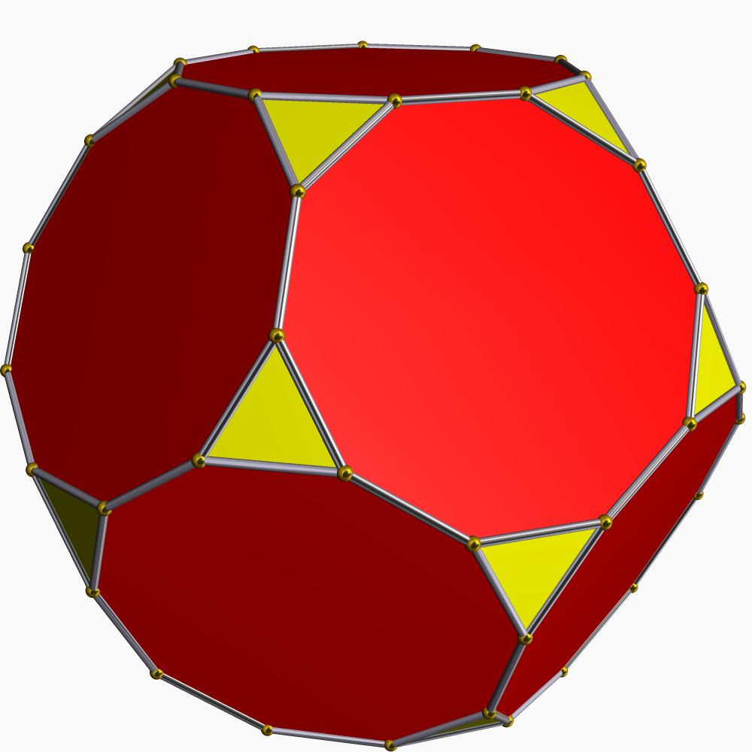
Truncated Dodecahedron
- 32 faces
- 90 edges
- 60 vertices
In dual polyhedra:
- Each face of one solid corresponds to a vertex of the other.
- Each vertex corresponds to a face.
- The number of edges remains the same.
Therefore, the Triakis Icosahedron has 60 faces and 32 vertices, while its dual has 32 faces and 60 vertices.

Constructing a Triakis Icosahedron

Geometric Instruments Used
# Source: AI Source: Provided by: [Data Path: Persons Table -> ID Column: 1, Name_En Column: Motasem Essam] -> From: [ChatGPT] on [7/25/2026]
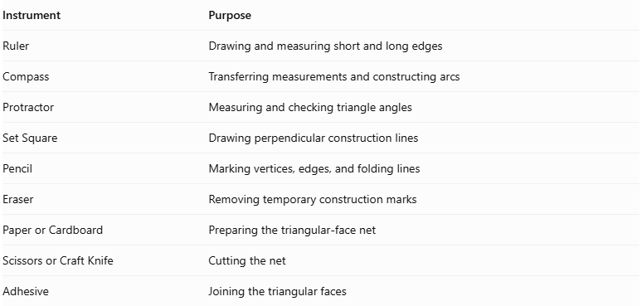
Instrument | Purpose
Ruler | Drawing and measuring short and long edges
Compass | Transferring measurements and constructing arcs
Protractor | Measuring and checking triangle angles
Set Square | Drawing perpendicular construction lines
Pencil | Marking vertices, edges, and folding lines
Eraser | Removing temporary construction marks
Paper or Cardboard | Preparing the triangular-face net
Scissors or Craft Knife | Cutting the net
Adhesive | Joining the triangular faces

Instrument-Based Construction Procedures

Method 1: Construction Using a Triangular Net
# Source: AI Source: Provided by: [Data Path: Persons Table -> ID Column: 1, Name_En Column: Motasem Essam] -> From: [ChatGPT] on [7/25/2026]
Step 1: Determine the Two Edge Lengths
- Select a common scale for the model.
- Establish a short edge length $s$ and a long edge length $l$.
- Use a ruler and compass to transfer both measurements.
For the standard Triakis Icosahedron, the ratio is:
$$\frac{s}{l}=\frac{8-φ}{11}$$
where $φ$ is the Golden Ratio:
$$φ=\frac{1+\sqrt{5}}{2}$$
$$\frac{s}{l}≈0.580$$
Step 2: Construct the First Isosceles Triangle
- Draw the long base edge using a ruler.
- Set the compass to the short edge length.
- Draw an arc from each endpoint of the base.
- Mark the intersection of the arcs.
- Connect the intersection to both endpoints.
This produces one isosceles triangular face.
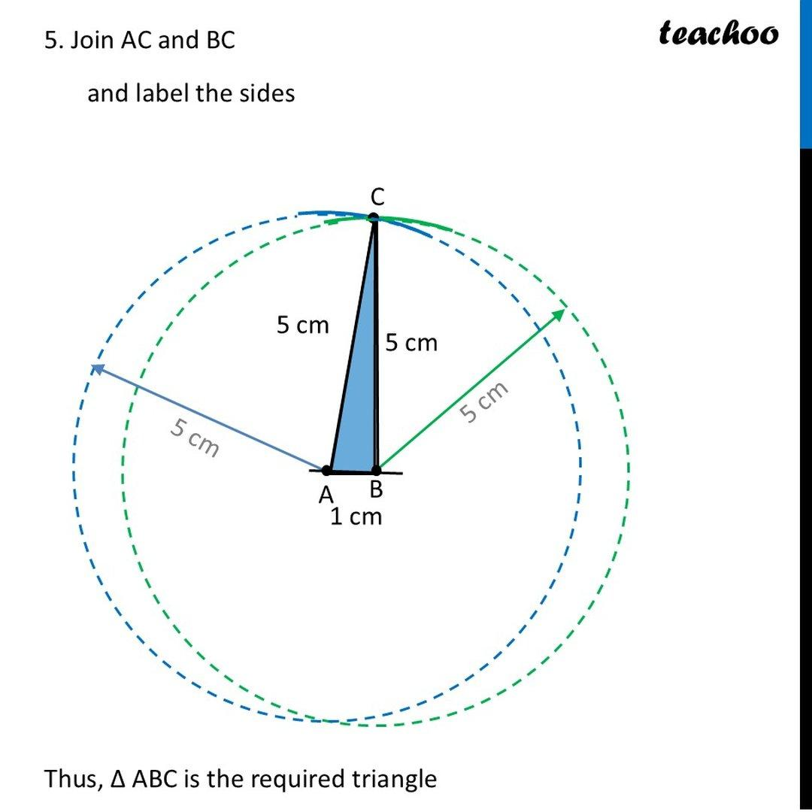
Step 3: Verify the Triangle Dimensions
- Confirm that the two shorter edges are equal.
- Check that the third edge is longer.
- Measure the interior angles using a protractor.
- Ensure that the triangle matches the standard Triakis Icosahedron face proportions.
Step 4: Construct the Remaining Faces
- Construct 59 additional congruent isosceles triangles.
- Maintain the same short and long edge lengths.
- Preserve the same orientation and face dimensions.
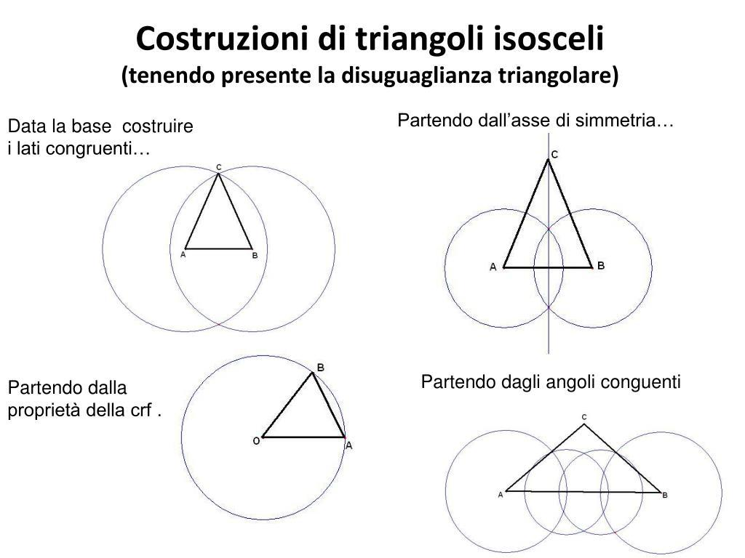
Step 5: Arrange the Triangular Faces
- Arrange all 60 triangles according to a valid Triakis Icosahedron net.
- Follow the correct edge-to-edge adjacency.
- Ensure that the net produces 20 trivalent vertices and 12 ten-valent vertices.
- Add joining tabs along selected outer edges.
Step 6: Cut Out the Net
- Cut around the external boundary.
- Preserve all joining tabs.
- Avoid cutting along the internal folding lines.
Step 7: Fold the Triangular Faces
- Fold along the shared edges.
- Raise the triangular faces gradually.
- Match the corresponding short and long edges.
- Maintain the correct orientation of the triangular faces.
Step 8: Join the Faces
- Apply adhesive to the joining tabs.
- Connect the corresponding edges.
- Allow the model to hold its three-dimensional shape.
Step 9: Complete the Solid
Verify the finished model:
- 60 triangular faces.
- 90 edges.
- 32 vertices.
- 60 short edges.
- 30 long edges.
- 20 trivalent vertices.
- 12 ten-valent vertices.
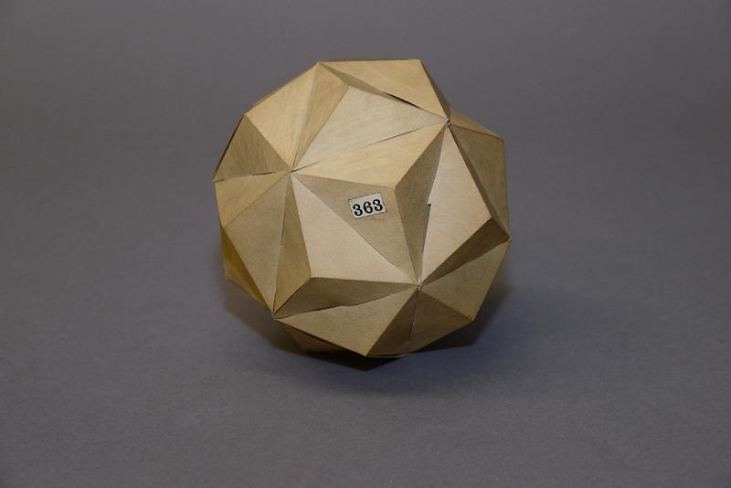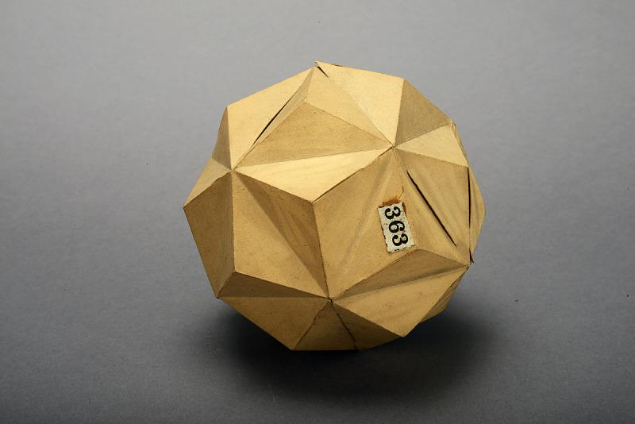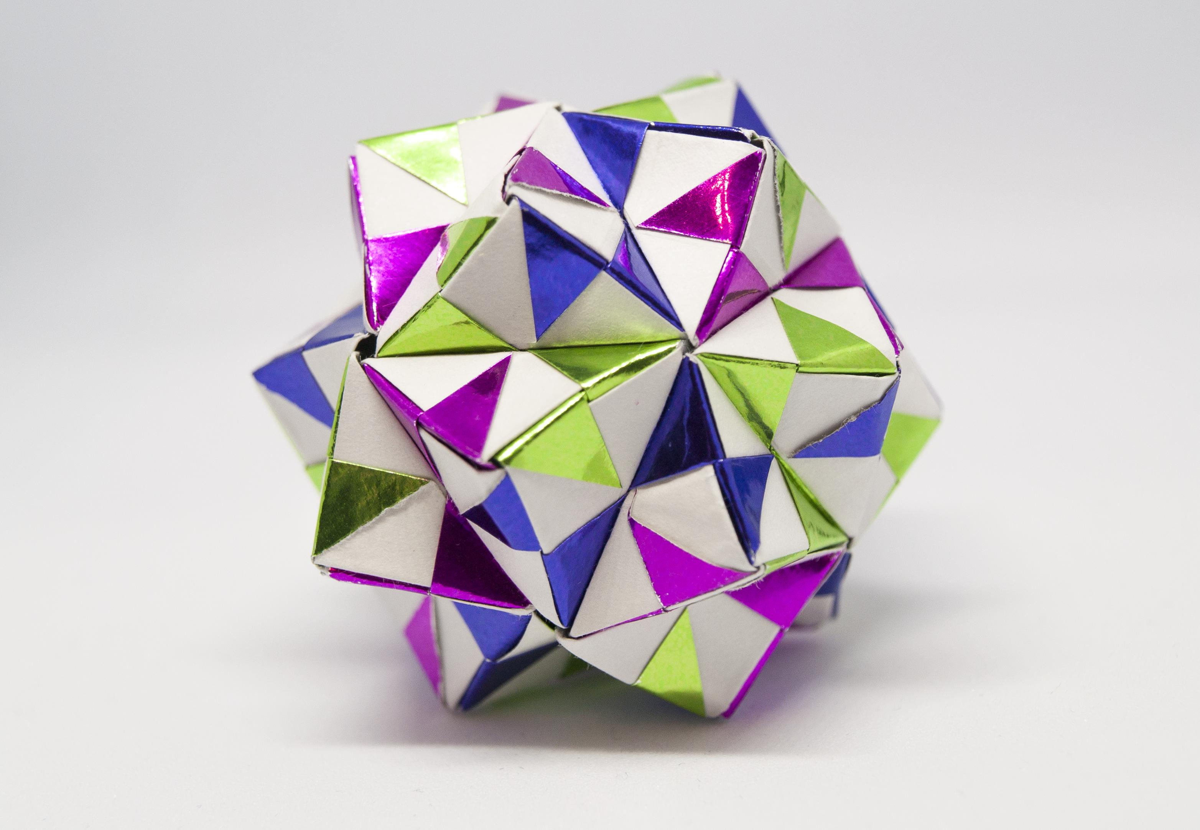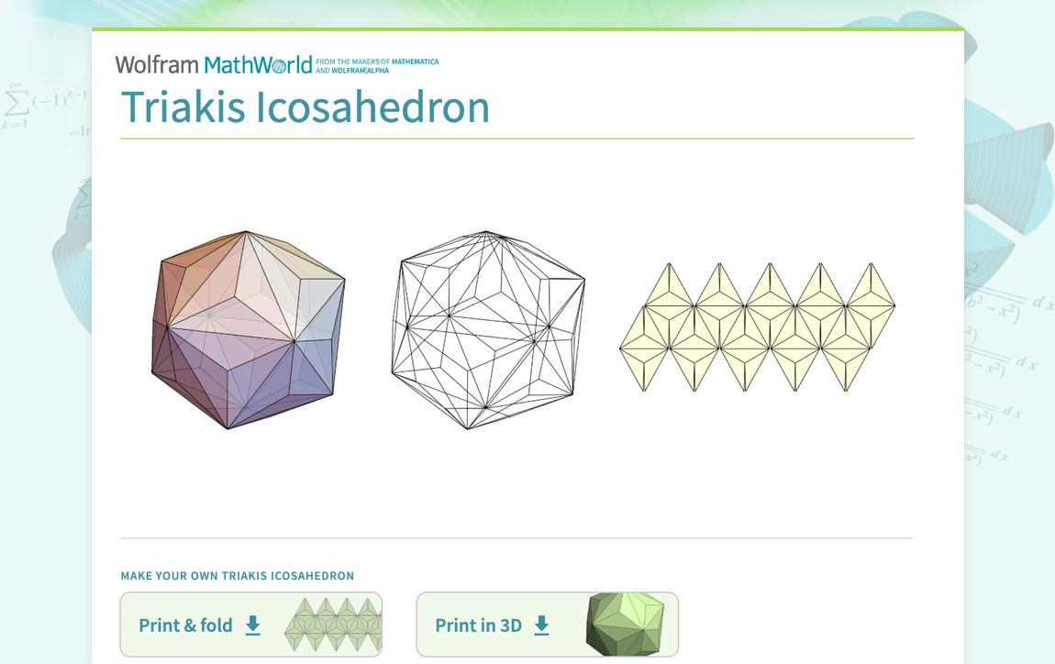

Method 2: Construction Using the Dual of a Truncated Dodecahedron
# Source: AI Source: Provided by: [Data Path: Persons Table -> ID Column: 1, Name_En Column: Motasem Essam] -> From: [ChatGPT] on [7/25/2026]
This method uses the dual relationship between the Truncated Dodecahedron and the Triakis Icosahedron.
Step 1: Construct the Truncated Dodecahedron
- Prepare a reference model of a Truncated Dodecahedron.
- Identify its 20 triangular faces and 12 regular decagonal faces.
- Verify its 60 vertices and 90 edges.
Step 2: Identify the Face Centers
- Mark the center of each of the 32 faces.
- Identify the perpendicular direction from each face center.
- Use the face centers as references for constructing the dual vertices.
Step 3: Establish the Dual Vertices
- Construct one dual vertex for each original face.
- Position each dual vertex along its corresponding face-normal direction.
- Apply the appropriate polar-dual scaling to preserve the standard proportions.
Step 4: Identify the Original Vertices
- Examine the 60 original vertices.
- Identify the three faces meeting at each vertex.
- Each original vertex corresponds to one triangular face in the dual.
Step 5: Connect the Dual Vertices
- Connect the three dual vertices associated with the faces surrounding each original vertex.
- Form one triangular face for each original vertex.
- Repeat for all 60 original vertices.
Step 6: Complete the Dual Structure
- Verify that all 60 triangular faces are formed.
- Check the 90 edges and 32 vertices.
- Confirm that all triangular faces are congruent isosceles triangles.
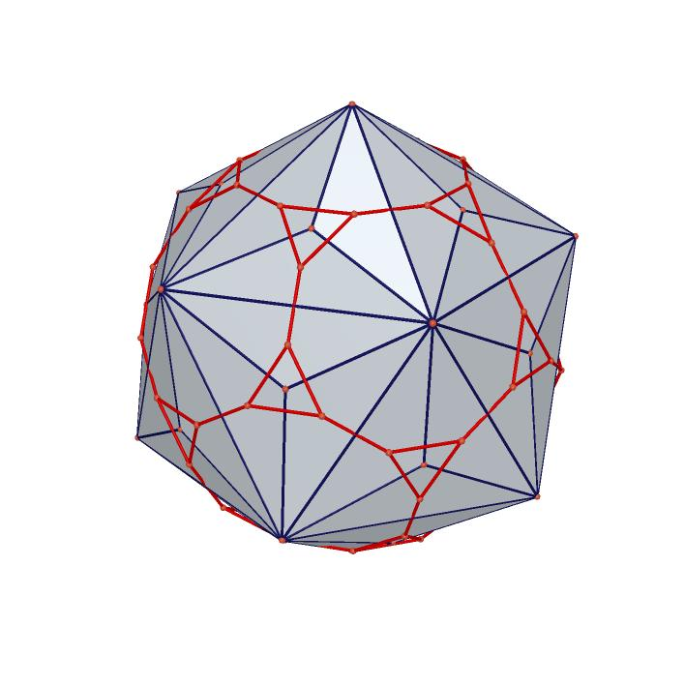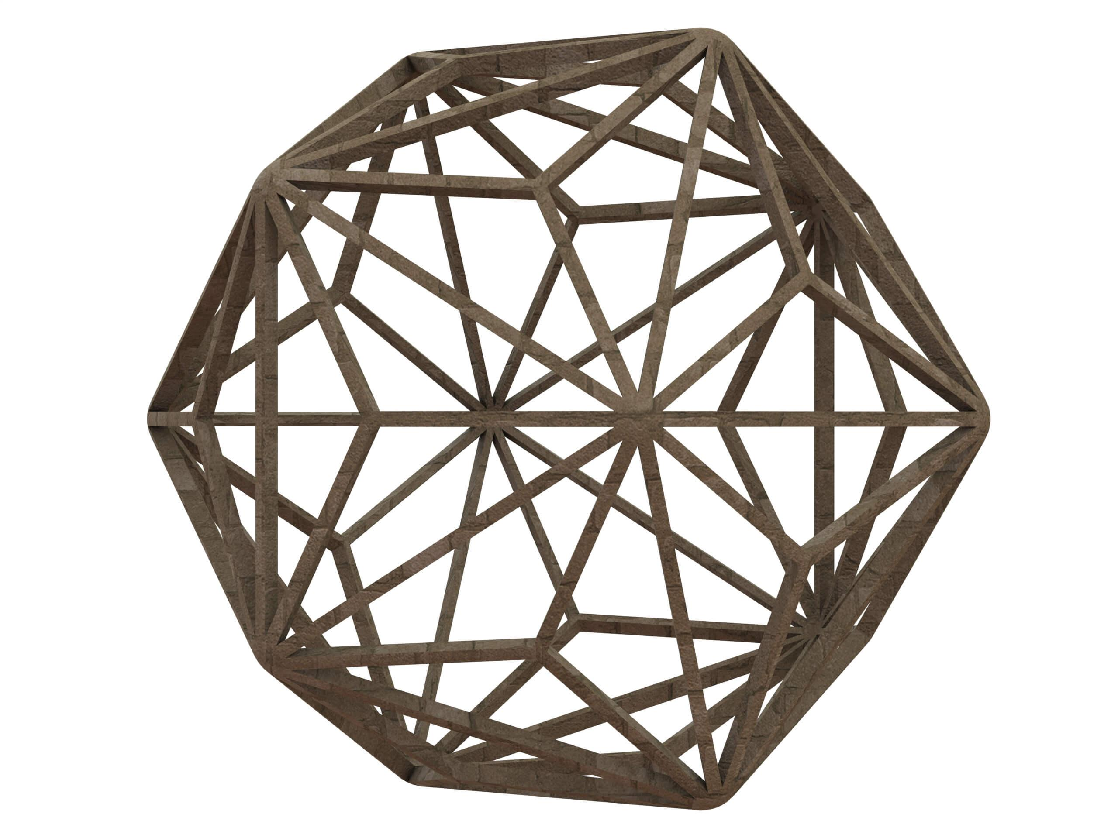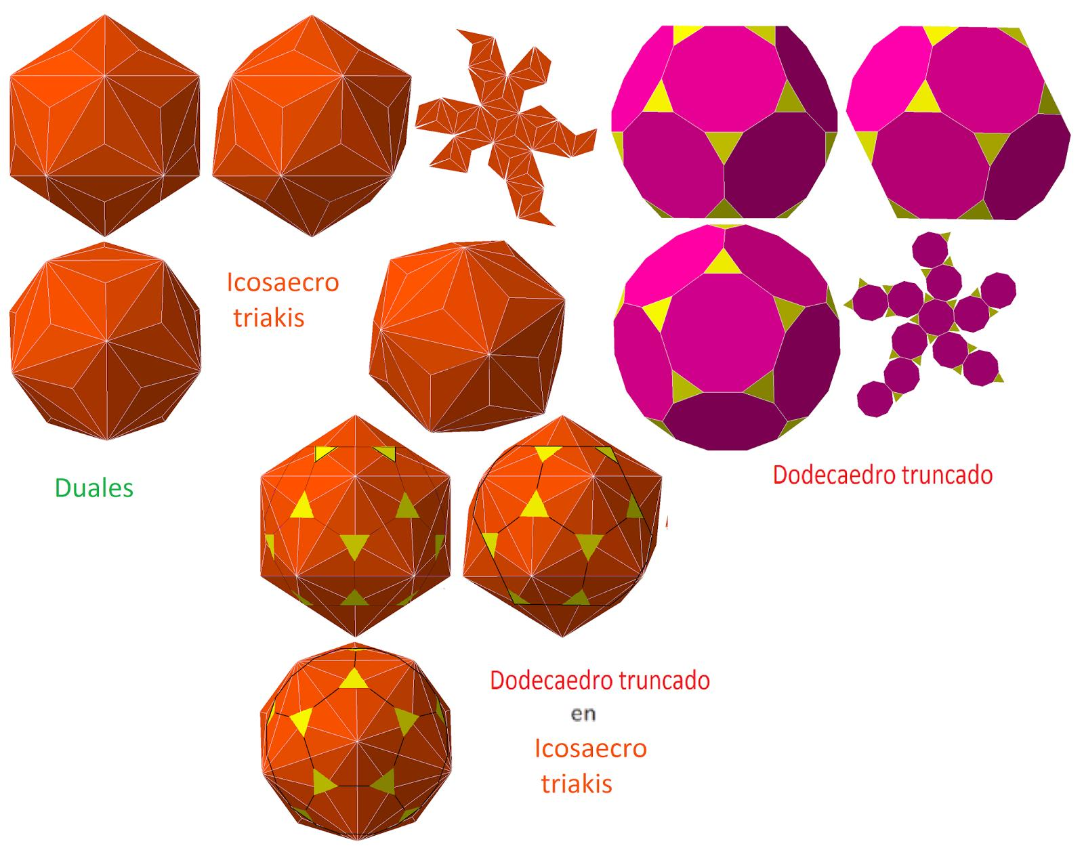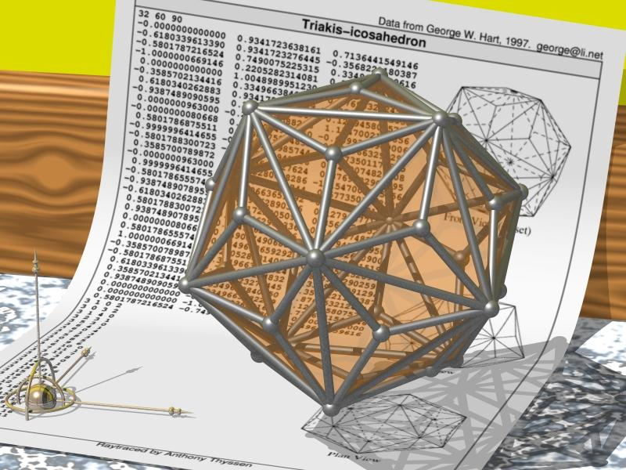
Important: Simply connecting the ordinary face centers does not necessarily produce the standard Triakis Icosahedron. The dual vertices must be positioned using the appropriate polar-dual construction.

Constructing a Triakis Icosahedron in Solid Geometry
# Source: AI Source: Provided by: [Data Path: Persons Table -> ID Column: 1, Name_En Column: Motasem Essam] -> From: [ChatGPT] on [7/25/2026]
One way to understand its construction is through its relationship to an icosahedron:
- Begin with a regular icosahedron.
- Identify its 20 triangular faces.
- Add a triangular pyramid to each face.
- Arrange the pyramid tips symmetrically.
- The resulting convex solid has 60 congruent isosceles triangular faces.
Another method is to construct the dual of a Truncated Dodecahedron by placing a point at the center of each face and connecting points corresponding to adjacent faces.
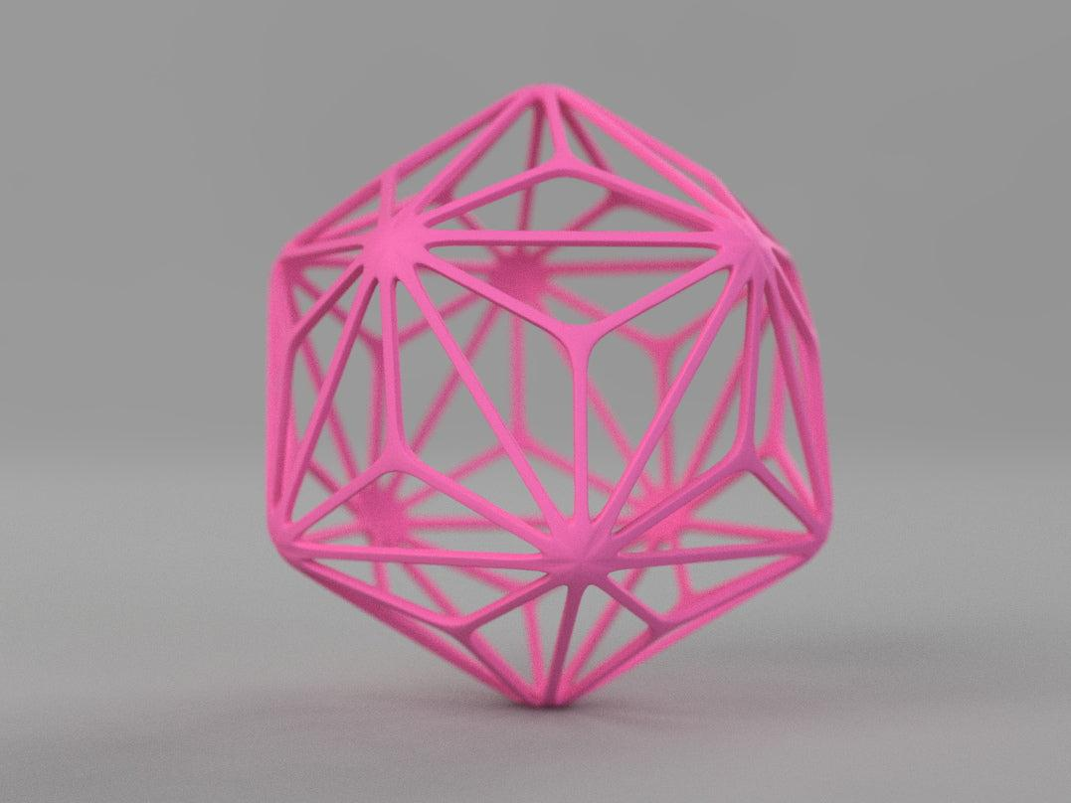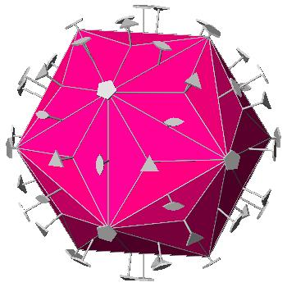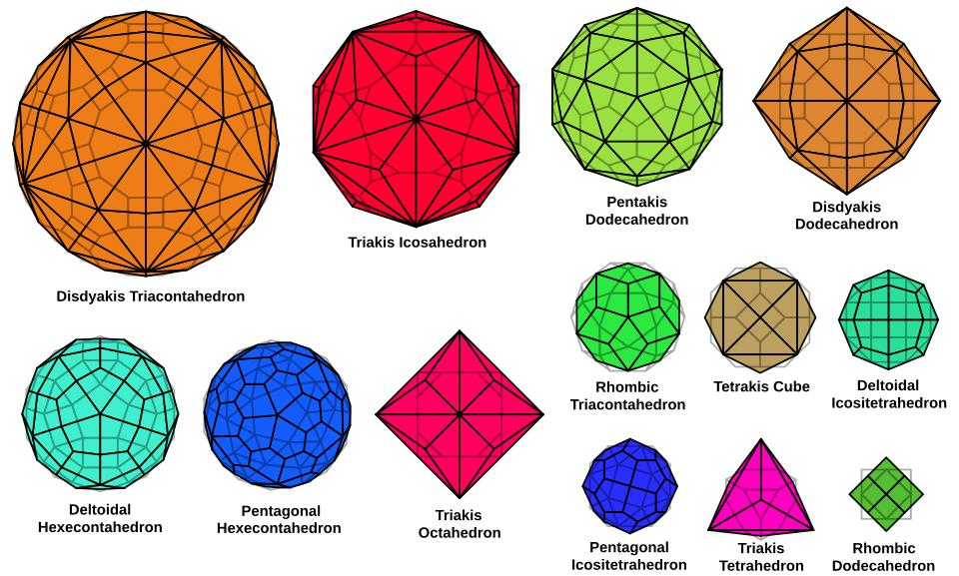

Key Points
# Source: AI Source: Provided by: [Data Path: Persons Table -> ID Column: 1, Name_En Column: Motasem Essam] -> From: [ChatGPT] on [7/25/2026]
- The Triakis Icosahedron is one of the 13 Catalan solids.
- It has 60 congruent isosceles triangular faces.
- It has 90 edges and 32 vertices.
- It has two different edge lengths.
- It has two types of vertices: 20 vertices of valence 3 and 12 vertices of valence 10.
- It is the dual of the Truncated Dodecahedron.
- It has full icosahedral symmetry $I_{h}$.
- It is a convex polyhedron.

Conclusion
# Source: AI Source: Provided by: [Data Path: Persons Table -> ID Column: 1, Name_En Column: Motasem Essam] -> From: [ChatGPT] on [7/25/2026]
The Triakis Icosahedron is a Catalan solid characterized by its 60 identical isosceles triangular faces and its distinctive combination of three-valence and ten-valence vertices. Its dual relationship with the Truncated Dodecahedron makes it an important example of polyhedral duality in solid geometry.

